Oak Park River Forest Food Pantry reveals bold new look
and mission-driven name

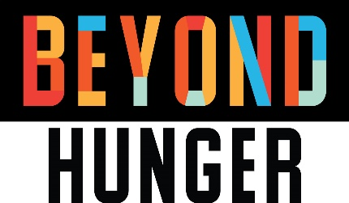

Oak Park River Forest Food Pantry recently unveiled a bold new name change to Beyond Hunger. The new identity reflects the evolution of the organization and its broader mission to harness the power of communities to end hunger in each of the 13 zip codes it serves.

Since the late 1970s, Oak Park River Forest Food Pantry has helped reduce food insecurity throughout Chicagoland by providing direct hunger relief services, hunger awareness education and advocacy. As the organization grew, the Food Pantry evolved to meet the changing needs of the surrounding communities. Oak Park River Forest Food Pantry now provides meals to 40,000 people each year in 13 zip codes in the greater Chicago area. The Food Pantry will continue to thrive as a program of Beyond Hunger providing access to healthy, nutritious food in a grocery store-like environment.

Beyond Hunger, a member of Hunger Free Communities Network, creates solutions to end hunger at every stage of life, including:

- OPRF Food Pantry
- Nutrition and health education
- Kids’ food programs, including schools and summer camps
- Home delivery to those with disabilities and older adults
- Social services
- Cooking classes
- Grocery shopping tours
- Health screenings
- Food rescue programs
- Advocacy for food security

You have a role in ending hunger! Have an hour every few months? Looking for something to do with the family on a Saturday? Have strong connections in the business community? Let’s think creatively and work together to end hunger. Visit GoBeyondHunger.org/makeadifference.

